Automobile Insurance Complaint & Premium Analysis Dashboard Power BI | Data Analytics Project
Junaid shaik
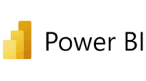
Business Problem
• Insurance companies receive different types of customer complaints every year. This project analyzes complaint trends, premium growth, and company performance to identify patterns and compare insurers.
Dataset
• Source: New York State Department of Financial Services (DFS) • Years Covered: 2009–2016
• Companies: 223
• Key fields:
• Premiums Written
• Total Complaints
• Upheld Complaints
• Complaint Ratio
• Ranking
Complaint Dashboard
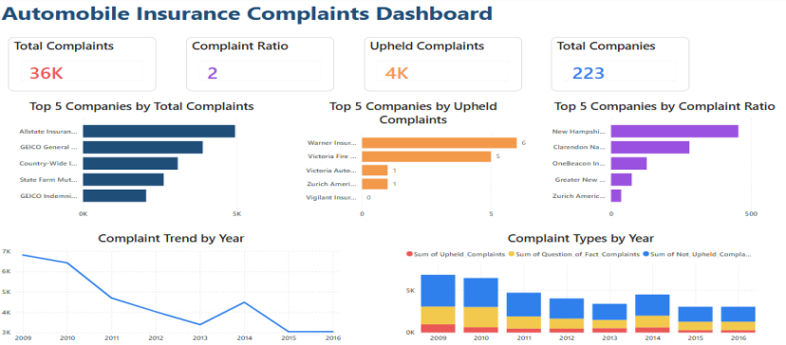Dashboard Highlights
•Complaint trends analyzed across 223 insurance companies (2009–2016).
•Compared the Top 5 companies by Total Complaints, Upheld Complaints, and Complaint Ratio. •Evaluated yearly complaint patterns by complaint outcome.
Premium Dashboard
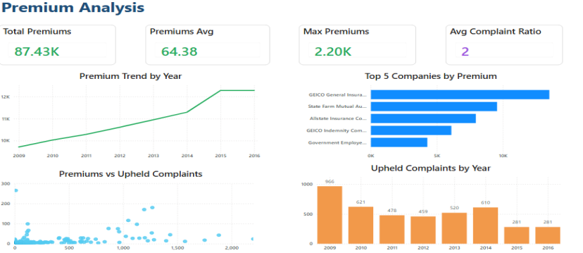Dashboard Highlights
• Analyzed premium trends over time.
• Identified the Top 5 companies by Premiums Written.
• Explored the relationship between Premiums and Upheld Complaints.
Comparison Dashboard
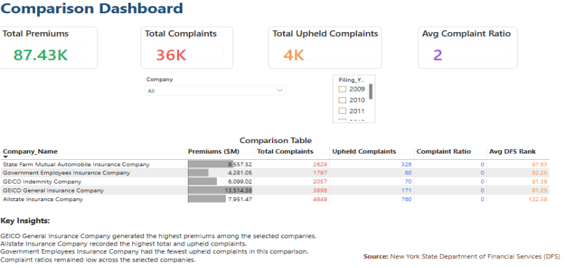
Dashboard Highlights
•Compared five insurance companies using key performance metrics.
•Interactive filters for company and year selection.
•Comparison table enables quick performance evaluation.
Key Insights
• Complaint volumes generally declined over the observed years.
• GEICO General Insurance Company recorded the highest premiums among the selected companies.
• Allstate Insurance Company recorded the highest complaint volume in the selected comparison. • Complaint ratios remained relatively low across most insurers.
Tools Used
• Power BI
• Power Query
• DAX
• Data Cleaning
• Data Visualization
Thank You!

